**DAILY ONLINE ACTIVITIES SUMMARY**

|  |  |  |  |  |  |  |  |  |
| --- | --- | --- | --- | --- | --- | --- | --- | --- |
| **Date:** | **14/06/2020** | | | | | **Name:** | **SUJAYA** | |
| **Sem & Sec** | **IV sem & B section** | | | | | **USN:** | **4AL18CS090** | |
| **Online Test Summary** | | | | | | | | |
| **Subject** | | **-** | | | | | | |
| **Max. Marks** | | **30** | | **Score** | | | **-** | |
| **Certification Course Summary** | | | | | | | | |
| **Course** | **Introduction to Ethical Hacking** | | | | | | | |
| **Certificate Provider** | | | **Greatlearning academy** | | **Duration** | | | **4.0 hours** |
| **Coding Challenges** | | | | | | | | |
| **Problem Statement1:** Write a C program to remove specific characters in the String. | | | | | | | | |
| **Status: Executed** | | | | | | | | |
| **Uploaded the report in Github** | | | | | **YES** | | | |
| **If yes Repository name** | | | | | **Online-coding** | | | |
| **Uploaded the report in slack** | | | | | **YES** | | | |

Online Test Summary: No internals conducted today.

Online Certification Course Summary: In today’s session I have learnt what is Ethical Hacking and also the demonstration of the same and also came to know about black hat, grey hat and white hat Hackers and also the goals of the Ethical Hacking.

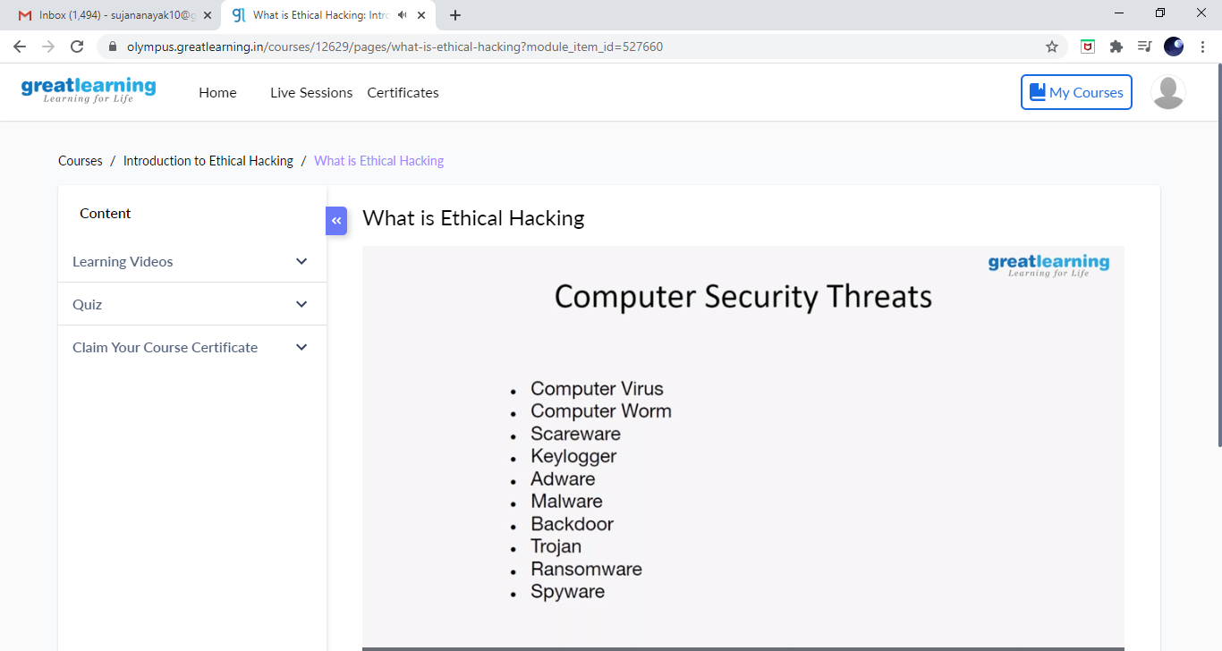

This is the Snap Shot of today’s session.

Online Coding Summary: **Today I had received one program from prof. Shilpa CSE Dept.The program is mentioned above in the coding challenges. I have also uploaded it to my Github repository.**

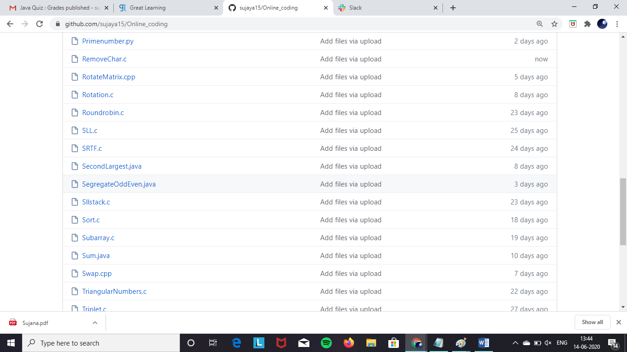

**This is the snap shot of my Github repository** were I have uploaded the code. File name is Removechar.c